
Company
Logotype

Cone Beam Computed Tomography- Report



Porur Dental X-rays & CBCT

Patient Name : Mr. Khaja Moideen | Date of Report : 18.08.2024
Age/ Gender : 38 years/ Male | Region of Interest : CBCT Mandible
Referring doctor: Dr. M. Balamurali Sai | Indication : Implant assessment- 35, 36, 37 and detection of proximal caries in 4th quadrant.
Clinical Notes: Nil
PATIENT INFORMATION

CBCT- Sectional Mandible provided
CBCT – IMAGE DETAILS

RADIOGRAPHIC INTERPRETATION

- Presence of hyperdense crown structure in relation to 34, 35, 36.
- Complete loss of crown and root structure in relation to 37.
- Presence of hyperdense restorative material within the pulp canal of 35 extending upto the apical third of the root is evident; in addition, a diffuse hypodensity is present in the periapical region of 35.
- The alveolar ridge in relation the mandibular alveolar ridge is present with normal trabecular pattern.

IMPLANT ASSESSMENT

 | 35 region | 36 region | 37 region
Sub-Crestal (in mm)
Width along the middle third of alveolar ridge
(in mm)
Distance between alveolar ridge and the inferior alveolar nerve canal (in mm)
Distance between alveolar ridge and the inferior border of mandible (in mm)

RADIOGRAPHIC IMPRESSION

- Root canal treated with interdental pathology: 35
- Crown: 35, 36, 37.
- Partially edentulous region: 37.

Kindly correlate with clinical findings


IMAGES FOR REFERENCE

RECONSTRUCTED PANORAMIC VIEW
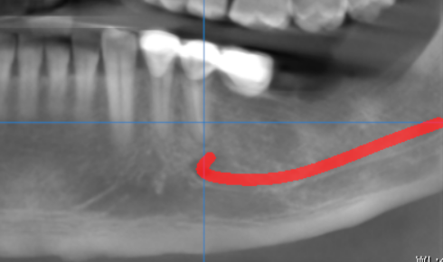

3-DIMENSIONAL VIEW

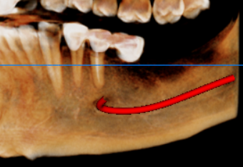

CROSS SECTIONAL VIEW

35 region | 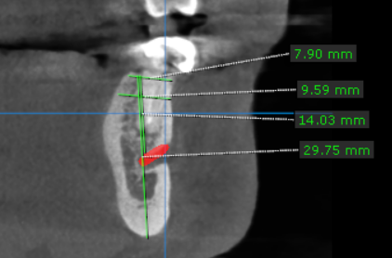
36 region | 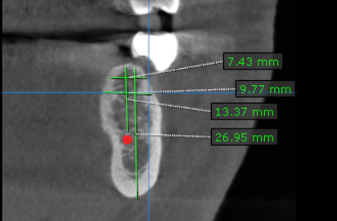
37 region | 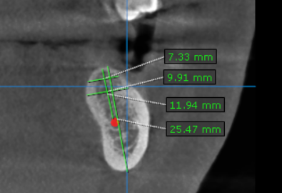

**** End of report ****

